ADD Authorization Codes –Instructions as of Fall 2019

At the beginning of the semester, you will receive an email from the Director of Admissions & Records. This email will have an attachment with Add Codes for every instructor. Find your name in the list (alphabetical by last name) & CRN for the course the student is wanting to add.

You are issued 12 codes per CRN. If you need additional codes, please contact the Director of Admission and Records. You will provide one code per student who wishes to add the course. It is the student’s responsibility to use the code to add and pay for the course. An example of an Add Code:

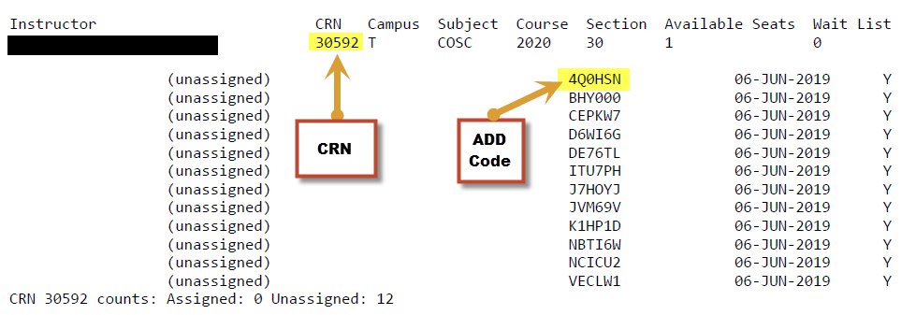

* If you have any questions, please contact Rebecca Murillo, Director of Admission and Records at 661-763-7870.