**Emergency Conditions Allowance (ECA) Summary:**

ECA Progress Report February 2023

Taft, College West Kern Community College District

In the fall of 2022, Taft College applied, and was approved, for the Chancellor’s Office Emergency Conditions Allowance (ECA). This allowance protects colleges from loss of FTES apportionment due to Covid, by using 2019-2020 apportionment to calculate 2022-2023 apportionment, and including this higher 2019-2020 FTES in the three-year rolling average used to calculate apportionment.

The application required colleges to submit detailed plans on student recruitment, retention, completion, community outreach, class scheduling, faculty training, and CVC-OEI status. The college is also required to confirm its ongoing audit and budget status, resources for student basic needs, Board policies, and more.

The application process specifically asked colleges to focus on how they will change and improve their current practices to better serve students, how they will absorb losses from covid, and how they will continue efforts to address diversity, equity, and inclusion within their districts.

**Updates on Taft College Activities to Increase Enrollment**

Outreach: Recruitment, Persistence, and Retention to Completion

Taft College continues to implement successful enrollment strategies, including offering dual enrollment classes. The college has increased the classes offered at the local high school, and has begun discussions with additional high schools to increase our dual enrollment presence. The Promise Program for graduating high school seniors is still in place. Summer camps for community children in grades 3-12 continues to be offered. Programming for elementary school children has increased, with an after-school program of STEM activities offered to students at Parkview Elementary School.

Additional ongoing planned activities outlined in the ECA application have been taking place. These include continuing outreach to new potential students and in-reach to current students to encourage both groups to enroll and complete their programs of study. Staff in Student Services areas, including Counseling, the Financial Aid Dept., and others, are all working on these projects. The Associated Students Organization has also held outreach and in-reach events, and coordinates student basic need resources planning.

Outreach:

* In November, the college took action to waive tuition for concurrent/dual enrollment for all high school students in the state. This is being publicized during outreach events.
* Free bus rides are now available, this is being publicized at outreach events.
* Hybrid counseling is in place, so students have the option to see a counselor online via Zoom, or in person on campus.
* Counseling outreach events for incoming freshmen at local high schools are planned for April and May, during which students receive academic counseling with creation of an education plan, and opportunity to register the same day.
* During February and March, the college is promoting application workshops throughout Kern County.
* The California Student Aid Commission (CSAC) has mandated that every graduating high school student will complete a Free Application for Federal Student Aid (FAFSA), so application workshops are being held during the academic year and the summer Cougar Day.
* Traditional high school outreach continues, with more than 50 events to date including visits to schools, campus tours, and a presence at college fairs.
* Student Services is hiring an Outreach Director to centralize event planning.
* The Associated Student Organization (ASO) is training two of their members to be student outreach ambassadors.
* Student Services now has two outreach ambassadors in place.
* Taft Union High School hosts a representative from the college every Friday to assist seniors with Taft College applications.
* The traditional Cougar Day one-stop outreach event has been extended to Cougar Week.
* A community open house, Community Night/Dia De Communidad, was held in December and included information tables for college programs and student services, free food, music, and other activities.

Persistence:

* Student Services staff members implemented “intrusive counseling” to increase persistence rates beginning in Spring 2022, by contacting non-returning students via emails and online in Zoom sessions. Information Technology Services Dept. at the college (ITS) identifies non-returning students. Student Services staff members call these students and offer a counseling meeting appointment.
* In Fall 2022, students were reminded to register on time via e-mail from Counseling staff members and the college website.
* Staff members from categorical programs at the college also reached out to their students to ensure they were enrolling in courses. Categorical programs include, e.g., EOPS (Extended Opportunity Programs and Services), DSPS (Disabled Students Programs and Services), and CalWORKS (California Work Opportunities and Responsibility to Kids Program).
* The Athletics Counselor met with all athletes to register them for courses.
  + - * A Counseling Education Plan campaign was put into place to encourage students to create long term education goal planning. About 95% of entering fall students completed an educational plan and all were recognized for reaching this milestone with an “I got a plan” t-shirt and planner.
      * In December student services hosted a “Celebrate the Student” campaign to encourage persistence by making students feel valued.
      * Workshop sessions were held focusing on AB540, DACA/DREAMer students.
      * Mental health and wellness counseling has been made available to students.

Completion:

* Long term Education Plans are offered to all students.  All students have access to counseling sessions. ITS provides Counseling with a roster of students who have completed an education plan and those who still need one. The goal is for all students to have a completed education plan.
* A class is offered annually to help students work toward planning their path toward a degree or certificate, STSU 1001 (one credit).
* DegreeWorks is a software system used to assist with educational planning.  Every education plan is in DegreeWorks and students have remote access to their plans, to assist with schedule planning and registration.
* Salesforce, a customer relationship management software system, has been implemented for use in contacting students for outreach toward completion.

Learning Center

Students have access to tutoring in the Learning Center for drop-in tutoring and for appointments, Monday and Thursday 8:00-6:30, Tuesday and Wednesday 8:00-5:00, and Friday 8:00-4:00. In response to student need, more classes have been assigned embedded tutors who work directly with students in specific classes (e.g., in History, Psychology, and Management classes). The Learning Center has also upgraded their record keeping system, TutorTrac, to a newer version for enhanced data collection, reporting, and scheduling and surveying.

Library

The library continues to serve students for their research and study needs. Open hours have been increased to provide availability from morning until the first hour of evening classes: Monday through Thursday 7:30-7:00, and Friday 7:30-4:00. The library continues to provide students with laptops, personal hotspots, calculators, and other DSPS learning assistance tools through regular library loan.

Basic Needs: Cougar Support Center and Veterans Resource Center

Students’ basic needs are addressed through the Cougar Support Center. The college recently increased their hours, increased the resources available, and hired a coordinator to oversee the Center. Open hours are Monday through Thursday 8:00-4:00 and Friday 8:00-2:00. Available resources include a food pantry, hygiene products, water, towels and blankets, clothing, grocery cards, gas cards, meal vouchers, and assistance with housing and mental health needs.

The college recently hired a Veterans Resource Center (VRC) coordinator and increased the open hours of the VRC, to provide stability to students who are military veterans. A separate space has been provided and renovated for VRC use.

Class Scheduling and Modality

The college has continued to offer both in-person and online classes. To better serve our in-person students, we have moved to a block scheduling system. This prevents time conflicts when classes might overlap. The scheduling allows students to take up to four classes in the mornings with no overlap or time conflict, and additional classes in the afternoon or evening. Enrollment has continued to decline since 2019, and the college is working to meet student preferences for flexibility in course scheduling. Our percent of online classes has risen from 46% in 2019 to 60% in the current semester.

Curriculum

Curriculum continues to be updated and reviewed. New programs in the process of being created and approved include Medical Assisting, Computer Science, Communications Studies, Graphic Design, and Law, Public Policy, and Society.

Work on the baccalaureate degree program for dental hygiene is making progress. The application has been submitted to the Chancellor’s Office and will be reviewed this spring. The substantive change proposal required by our accreditation agency, ACCJC, was submitted and has been approved.

Ideas for CTE programs arise from the college staff and faculty, industry partners, the community at large, and external agencies. As ideas are brough forward, the Dean of Instruction and CTE and the CTE Committee explore their viability, in an ongoing effort to create programs and certificates for job readiness that meet the needs of students and the community.

In recent months, the college has received sever grants related to curriculum development. These include the K-16 Collaborative grant, which we are using the create the medical assisting grant. The Community Economic Resilience Fund (CERF) is being used for EMT development and updating and exploration of a paramedic program. As a member of CVHEC (Central Valley Higher Education Consortium) we are one of six colleges in planning phases for a grant funded “math bridge” dual enrollment program. The UP-LIFT CA grant (Universities and Partners Learning, Innovating, Fostering Equity, Transforming California Early Childhood Education Degrees) is active now, developing curriculum for classes teaching students who want to become early childhood educators how to work more effectively with dual language learners.

Diversity, Equity, Inclusion

The college DEIAA Committee (Diversity, Equity, Inclusion, Accessibility, Anti-Racism) has created a web page for instructors to find teaching resources, to promote discussion, and disseminate information. They have also planned an outreach event for male students, who are underrepresented in college enrollments, to make connections with the college. Their first high school male summit takes place in March. The ASO has begun a Student Cultural Empowerment discussion group for students to focus on diversity, equity, and inclusion topics. The Distance Education Dept. offers ongoing training to make documents and materials accessible to readers with disabilities.

Remote Teaching and Learning Training

The Distance Education (DE) Department and the Office of Instruction, led by the Vice President of Instruction, continue to provide training to improve teaching, with emphasis on providing a better learning environment for our online students. Training is available online through CVC-OEI@One, and workshops are also provided on campus to faculty. Topics for upcoming DE workshops include Universal Design for Learning (UDL), Pope Tech Web Accessibility Training, Using Canvas Studio, and Improving Your Course Through POCR (Peer Online Course Review). Lunch ‘n Learn opportunities for faculty address best practices in online and in-person teaching. Upcoming sessions will address structing smaller in-person classes differently for higher success rates, and the use of ChatGPT (artificial intelligence) in higher education.

Marketing

To continue testing the perceived positive effect of marketing on enrollment numbers, the college is extending the delivery of more than 19 million total communications messages on multiple digital and traditional platforms through the end of 2023 and into 2024.

Since COVID-19 numbers have dropped significantly, Taft College is currently shifting some of its digital channel communications back to traditional media channels to further broaden reach and better target specific audiences through their preferred channels, including newspaper, magazine, outdoor, and radio in English and Spanish.

Our primary media partners, iHeartMedia, American General Media, and Sinclair Broadcast Group, are continuing deployment of marketing and communications messaging across five radio stations, monthly e-mail, online video, video pre-roll, display ads, TV programming, Amazon Over-the-top (OTT) streaming internet, mobile messaging, social mirroring, live athletics interviews on ESPN’s Greg Kerr Show, and live interviews on local KBAK/KBFX newscasts. The “Education Matters” sponsorship on KBAK/KBFX also continues. Contracts with new media partners, Lotus Radio Bakersfield and Lamar Outdoor, have been signed for Spanish radio and outdoor billboard advertising, respectively.

Taft College also has new annual contracts in place with Taft Independent Newspaper, Taft Midway Driller, and Kern High School District Achieve Magazine for local print and online advertising opportunities. Original and curated social media posts on Facebook, LinkedIn, Twitter, Instagram, and YouTube continue daily and are shared frequently to external partner platforms.

Multiple internal and external resources are now focused on launching Taft College’s new, primary website in the third quarter of 2023, if not sooner. New content across the site is being developed to better communicate the various features and benefits of each of the academic programs, student support services, and student life at the college, to name a few, as well as the lifelong economic benefits of earning a Taft College degree. New page design templates, creative photography, and videos are being developed to immediately portray a positive and diverse student experience across the site.

The organization of information on the new website has been revamped to deliver information to audiences within just a few clicks and through multiple means. Training for content managers has begun on the Omni Content Management System (CMS) on which the new Taft College website is being built. With the launch of the new site will come a greater focus on communicating Taft College News and Events on a regular basis. An events strategy that regularly brings local constituent groups to campus is now possible since the COVID-19 pandemic is waning.

**Budget and Board Policy**

The Budget Committee, led by the college Vice President of Administrative Services, set a goal to monitor the current situation with ECA as it relates to the Student-Centered Funding Formula. To that end, the committee decided to make a standing agenda item for reporting progress on ECA.

The college has submitted required financial reports and submitted the audit reports as required by the ECA. Regarding required financial elements for the ECA, the college is on schedule and in compliance with our ECA plan.

The Board of Trustees updated Boad Policy (BP) 6250, Budget Management, on 8/10/22. The updated BP meets the ECA requirements on unrestricted general fund reserves.

**California Virtual Campus - Open Education Initiative (CVC-OEI):**

As explained by the California Community College Chancellor’s Office, “The California Virtual Campus-Online Education Initiative (CVC-OEI) is a collaborative effort among California Community Colleges (CCCs) to ensure that significantly more students are able to complete their educational goals by increasing both access to and success in high-quality online courses. The CVC-OEI represents a comprehensive and collaborative program that leverages effective practices and technology to significantly increase the opportunity for higher education degree attainment in California.”

According to the ECA directive related to CVC-OEI, the college/district meets the conditions pertaining to the CVC if it:

1. is a member of the CVC-OEI Consortium and has signed the Master Consortium Agreement.
2. has implemented the steps to become a Home College and has implemented or committed to 1) enabling Course Finder API, 2) completing the steps needed to become Teaching College ready, and 3) joining a scheduled implementation cohort to become a Teaching College, by the beginning of the first term that starts on or after January 01, 2023.

The CVC defines “committing to” to mean that the process has been started by the college/district and is in progress. Here the benchmarks for the ECA and our status:

1. Consortium Member - Yes
2. Home College - Complete
3. Financial Aid Agreement - Signed
4. Course Finder API - In Progress
5. SuperGlue & eTranscript Sending (Teaching College Ready) - Only SuperGlue
6. Teaching College Cohort Scheduled - May 2024
7. Teaching College - Not yet
8. All CVC Requirements Met - Not yet

The college is currently making great progress in our effort to become a teaching college within the CVC-OEI system. Information Technology Services (ITS) is currently working with the CVC-OEI team on the CVC Course Finder Implementation Plan. This is crucial to listing enable all courses accurately on the CVC Course Finder with live seat counts. There are four phases to the plan: (1) Orientation; (2) Installation and Configuration Tasks; (3) Data Discovery, Integration, and Testing Tasks; (4) Production and Integration Tasks.

The college has successfully completed the first two phases and is on the final step of phase three. The CVC-OEI has been able to successfully import our Spring 2023 course inventory into the CVC Exchange Staging UI (test environment). We are now in the process of reviewing the results of the import to identify and correct any errors before promoting this work to our production systems and allowing us to go live. Once ITS staff have completed the CVC Course Finder Implementation Plan, we will shift our focus to Cross-Enrollment. This will be the registration phase in which the focus will be enabling:

* one-click add/drop for online classes,
* no separate application process,
* use of the teaching college’s payment processor,
* option to combine units for Financial Aid packaging.

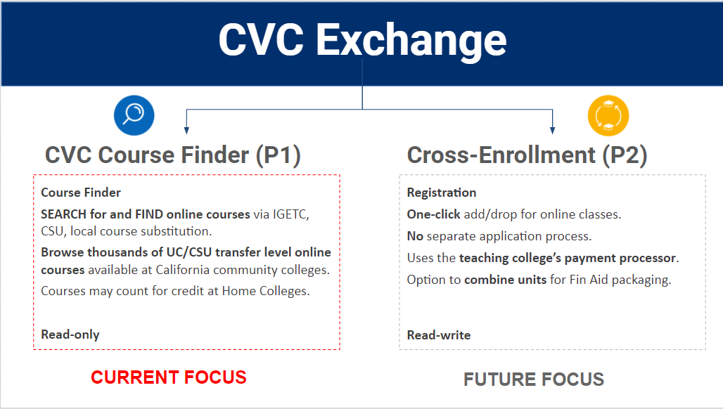

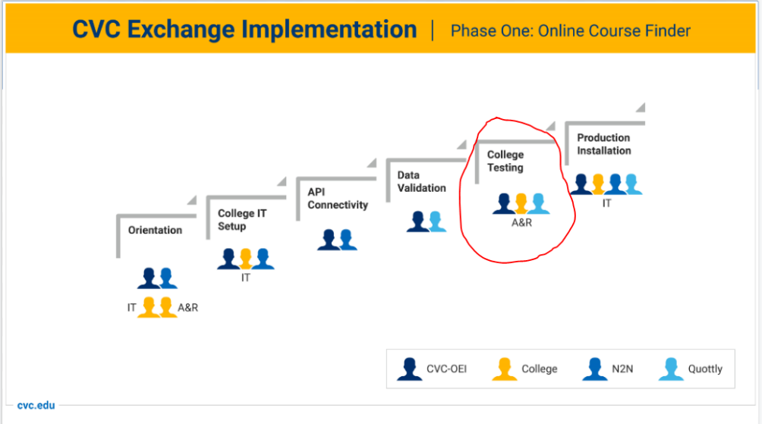

**Summary**

Taft College continues to work toward recovery from the effects of the pandemic and resulting declining enrollment. We have increased our outreach efforts, and activities to improve retention and completion. Our marketing efforts respond to changing student interest and demographics. Class scheduling, modality, and instructor training are responsive to student and instructor needs. Grants and curriculum development are both ongoing. Student resources and supports are in place and have been increased. DEI/DEIAA work continues among students, staff, and faculty. We continue to maintain the financial requirements of the ECA, and are on track in our CVC-OEI work to meet requirements ahead of time.