**Tests Due During the**

**Week of *December 2 - 6,* 2019**

**Week # 15**

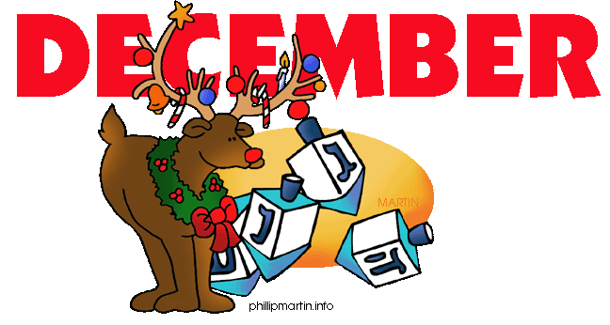

|  |  |  |  |
| --- | --- | --- | --- |
| **Course** | **Instructor Name** | **Test Number** | **Due Date** |
| MATH 1500 | Jones, D. | Cha 8 | 12/5 |
| SPAN 1601 | Martinez, J. | Final | 12/2 |
|  |  |  |  |
|  |  |  |  |
|  |  |  |  |
|  |  |  |  |
|  |  |  |  |

**Note**: **Due dates are shown above but always check your syllabus for accuracy**