Instructions for Login and Access to Adobe Student Licensing of Creative Cloud for New Users

Please follow these download instructions to gain access to your Adobe License. Please read all six steps before continuing as there are important prompts that appear and can cause issues if the wrong option is selected.

1) Check your email for the “Welcome” email from Adobe and click “Get Started.” You should have received one when your account was activated. It will look like the screenshot below.

If you did not receive the email, go to <https://creativecloud.adobe.com/apps/all/desktop>.

2) You will be taken to a page asking you to sign in. Create your password.

If you went to the URL in step one, log in with the email associated with your purchase.

(It may ask you to verify your account with a verification code. Follow those directions.)

3) If you see the prompt below, choose “Personal.” (This prompt may not appear depending on your email address)

4) When prompted, choose “Join Team” as shown below.

5) After joining the team, choose “Continue” as shown below.

6) Choose the “FCCC – Foundation for California Community Colleges” profile as shown below.

7) You should now see the list of available apps with “Install” next to all of them. If you do not, please try signing out of your account on the web app [here](https://creativecloud.adobe.com/apps/all/desktop) and the desktop app. Then, sign back in and repeat the steps above.

Mobile Application Access

All applications in the creative cloud are included in your subscription -- desktop, cloud based, and mobile apps. You can follow the link below on your phone or tablet to download the mobile versions of Photoshop, Lightroom, and much more.

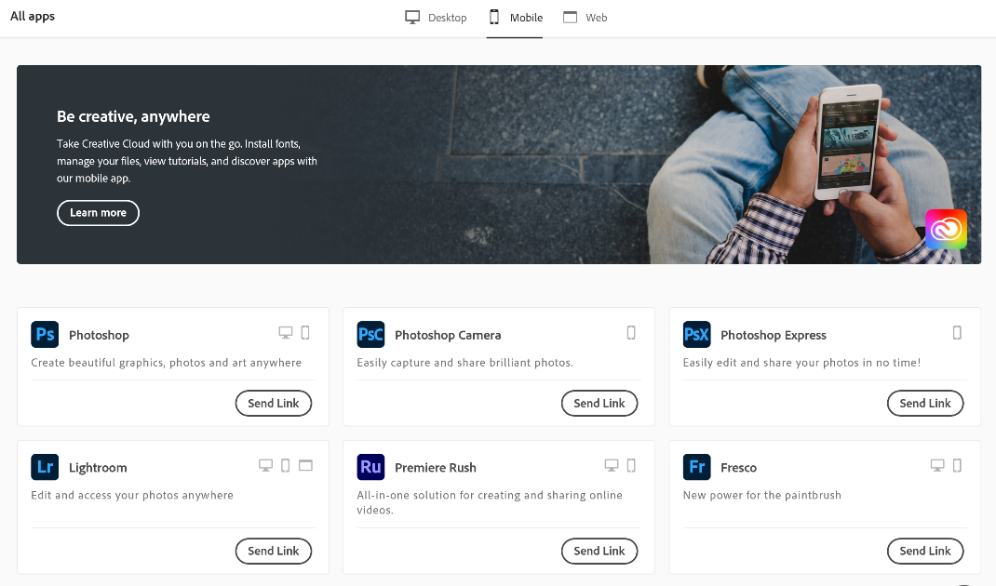

|  |
| --- |
| [Android Mobile Apps](https://play.google.com/store/apps/details?id=com.adobe.cc) |

|  |
| --- |
| [Apple Mobile Apps (iPhone/ iPad)](https://apps.apple.com/us/app/adobe-creative-cloud/id852473028) |